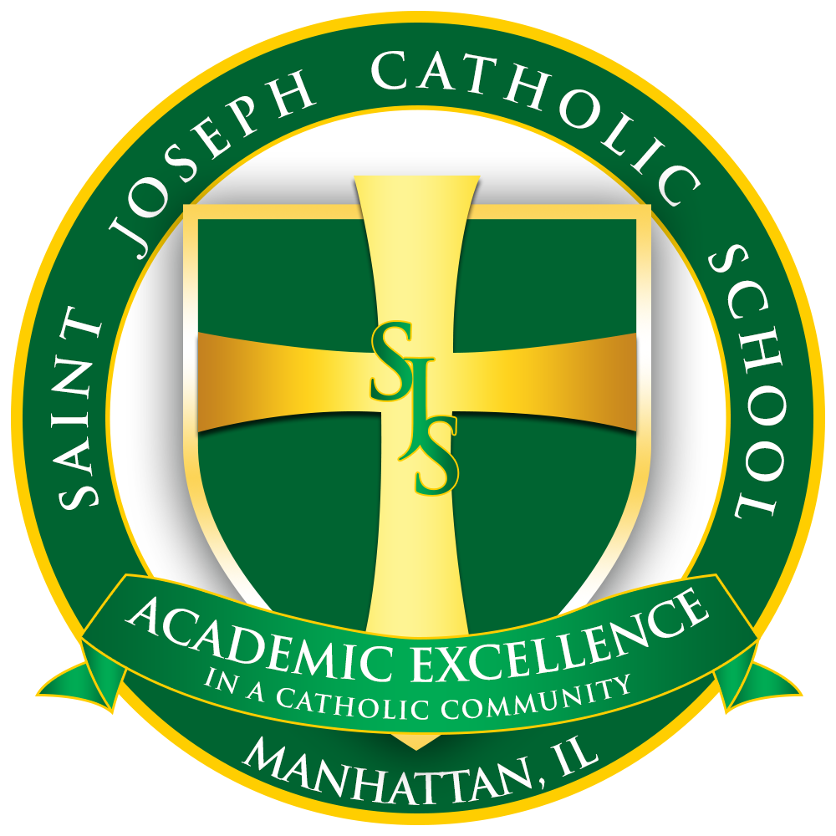
St. Joseph School
275 W. North Street
Manhattan IL, 60442
www.sjsmanhattan.org

Dear Prospective Family,

At St. Joseph Catholic School, our students and families continue to be a testament to the strong family oriented values that reinforce the spiritual and intellectual development of all of our students. I invite you to see for yourself the many opportunities for excellence St. Joseph School has to offer.

One of the most crucial decisions you will make as parents is how and where to find the best possible environment in which to educate your child. As you continue to search educational options, please know that St. Joseph offers families so much more. Our school mission states,

St. Joseph School exists for the purpose of providing the highest level attainable of spiritual and intellectual development of the children we serve. Our goal of providing academic excellence within a Catholic environment is facilitated by strong family involvement, thereby creating an atmosphere of hope, mutual respect, caring, love of Jesus Christ, self and each other.

Our students and the students attending the schools in the Diocese of Joliet achieve an average ACT Score of 25. We are proud of our Diocese of Joliet graduation rate of 99% as well as 99% of our St. Joseph graduates attend a four-year college or university. These accomplishments do not happen without a challenging and vibrant curriculum all through grammar school years. Our students are provided with a balance of both challenging courses and a nurturing environment. Our curriculum is tailored to individual instruction, comprehensive monitoring of student progress and meeting the needs of every student.

Our family friendly community opens its doors to parents and grandparents, interested in volunteering and playing a more active role in the lives our students. Through the leadership and guidance of our dedicated and knowledgeable teachers and staff, the unending support and efforts of our parents, and the commitment of our parish, the entire St. Joseph community works to create the best academic and spiritual experience for our students.

A Catholic Education is more affordable than ever. Last year alone St. Joseph School offered 16 student scholars a total of $10,200.00 in tuition assistance. Scholarship applications are available for all families. And we are currently offering a $1,500 grant to new students. $1,000 will be applied to this year’s tuition and $500.00 will be added to next fall.

We encourage and welcome you to come take a look for yourself at all of the wonderful things that St. Joseph School has to offer. Please contact the school office for a guided tour, to set up a student shadow day or to register for next fall. Thank you.

Mrs. Colleen Domke
St. Joseph School
(815) 478-3951

